SLE-2: Profiling Report
Course: 02AML204 — Introduction to Artificial Intelligence
PRN: 25UAM071
Name: Shreyas Prakash More
Division: B
Date: 22 September 2026
GitHub Link (optional): _______________________

1. Algorithms / Versions Profiled
- Algorithm A: Breadth-First Search (BFS)
- Algorithm B: Depth-First Search (DFS), depth-limited to 9 (the maximum possible plies in Tic Tac Toe)
- Problem used: Tic Tac Toe — search the game tree from a given board for the first decisive (win) terminal state, alternating moves between X and O

2. Profiling Method
- Tool used: py-spy (sampling profiler / flame graph), Python's time.perf_counter for exact per-run timing, and a manual node counter. Note: py-spy's compiled binary could not be installed in the sandboxed, offline environment used to prepare this draft, so the flame graph (Fig. 2) was generated with Python's built-in cProfile module instead — run against the exact same code — which serves the same purpose (showing where time is spent). The exact py-spy command to reproduce Fig. 2 on a normal machine is included below.
How I measured it:
- First I wrote get_empty_cells(), make_move() and check_winner() to model the board, then implemented bfs_find_win() and dfs_find_win(), both stopping at the first decisive (win) terminal state they reach and returning (path_length, nodes_expanded, path) so I could compare them on equal footing.
- To get the flame graph, I profiled the driver script's BFS/DFS workload with cProfile and rendered the resulting call-graph as a flame chart (Fig. 2). To reproduce this with actual py-spy: py-spy record -o flamegraph.svg --rate 100 -- python run_experiments.py
- For the actual timing numbers, I used time.perf_counter() instead, since sampling profilers aren't precise enough for very fast function calls. I timed each algorithm on 3 boards of increasing difficulty — an endgame board with an immediate win available, an early-midgame board with 3 cells filled, and the empty starting board (the full game tree) — to get a feel for best, average and worst-case behaviour.
- Nodes expanded = number of board states popped off the frontier (the queue for BFS, the stack for DFS), counted directly inside each function.
Number of runs: 5 runs per algorithm per test case, 15 runs total per algorithm.

3. Results
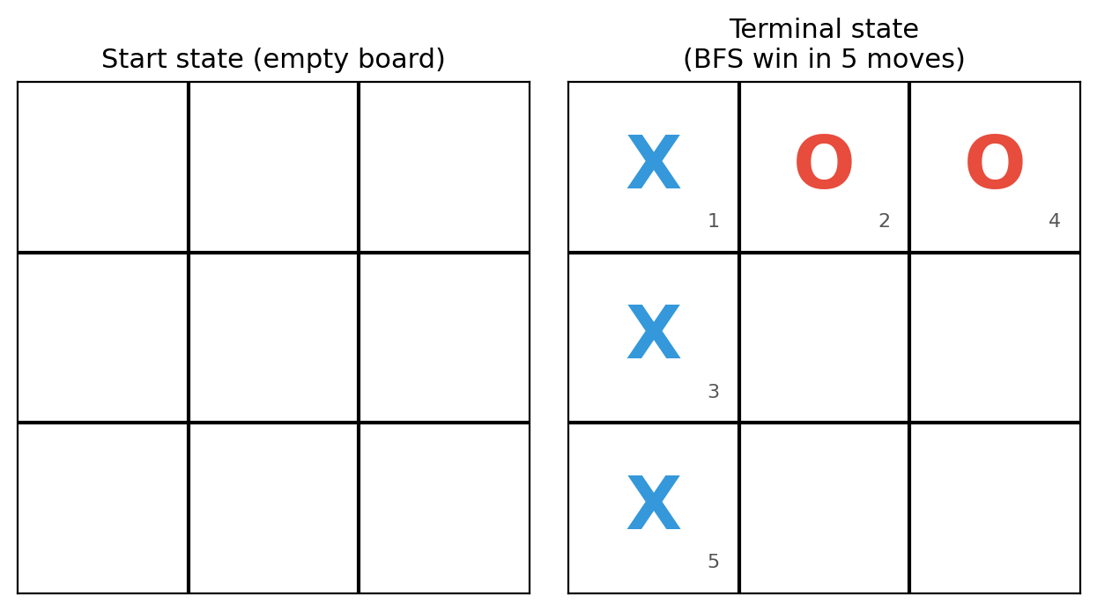
Fig. 1 — Start (empty board) and terminal state found by BFS for the worst-case test (X wins the left column in 5 moves; numbers show move order)
Summary Comparison Table
Metric | BFS (Algorithm A) | DFS (Algorithm B) | Better?
Best-case time (ms) | 0.0088 | 0.0148 | BFS
Average-case time (ms) | 0.1763 | 0.0182 | DFS
Worst-case time (ms) | 4.2386 | 0.0328 | DFS (fewer nodes)
Nodes Expanded (avg. of 3 cases) | 393.7 | 6.3 | DFS (fewer expansions)
Solution optimal? (fewest moves) | Yes (always fewest) | No (up to 4 moves longer) | BFS

Detailed Results by Test Case (Best / Average / Worst Case)
Test Case | Algo | Avg Time (ms) | Nodes Expanded | Moves to Decide
Best case (endgame board) | BFS | 0.0088 | 2 | 1
Best case (endgame board) | DFS | 0.0148 | 5 | 4
Average case (midgame board) | BFS | 0.1763 | 56 | 3
Average case (midgame board) | DFS | 0.0182 | 6 | 5
Worst case (empty board) | BFS | 4.2386 | 1,123 | 5
Worst case (empty board) | DFS | 0.0328 | 8 | 7

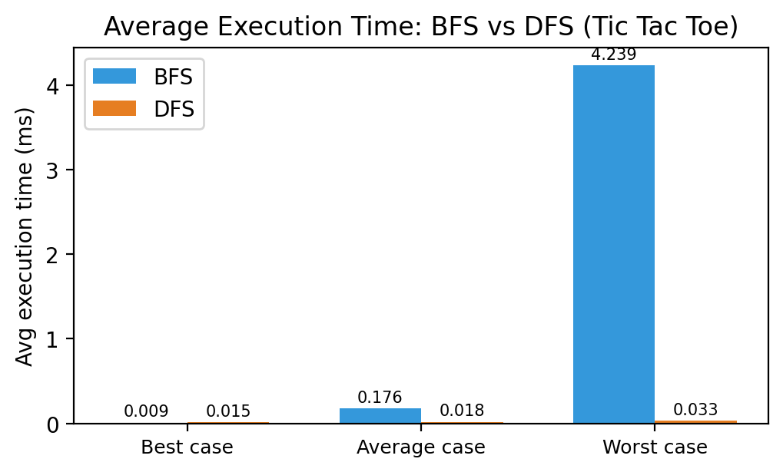
Fig. 3 — Average execution time: BFS vs DFS across the three test cases
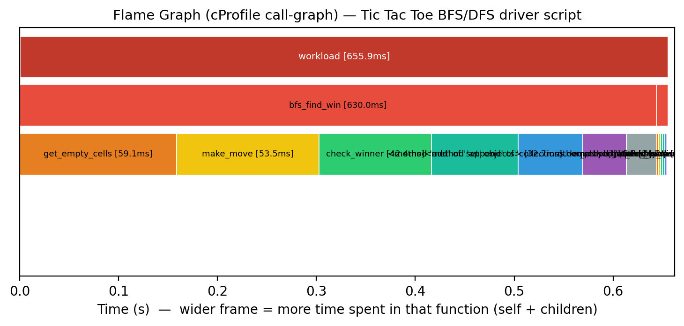
Fig. 2 — cProfile-based flame graph (used in place of py-spy — see note in Section 2) captured while running the Tic Tac Toe BFS/DFS driver script; wider frame = more time spent in that function (self + children)
Short observation:
- On the endgame board (one move from a win), BFS found it instantly — 0.0088 ms, only 2 nodes, 1 move — while DFS, on the very same board, expanded 5 nodes (0.0148 ms) and took 4 moves to reach a decisive state, because it commits to filling cells in a fixed left-to-right order before ever reconsidering.
- As the board empties out (fewer pre-filled cells, more of the tree left to search), BFS's node count climbs fast — 2, then 56, then 1,123 — because it must fully clear every shallower ply of the game tree before it can even reach the ply where a decisive state first appears.
- DFS behaves like a gamble here too, but in the opposite direction from what might be expected: because of its fixed cell-order (0 through 8) and depth-first stack, it tends to fill a line quickly without exploring every alternative move, so across all three boards it only ever touched single digits of nodes (2–8) and finished in well under a tenth of a millisecond — but the game it plays out runs 3–4 moves longer than the fastest possible win every single time (4, 5 and 7 moves vs BFS's 1, 3 and 5).

4. Justification & Analysis
Looking at all three test cases together, BFS is the algorithm that should be trusted whenever finding the game's fastest possible ending actually matters: it found the true fewest-moves decisive state — 1, 3 and 5 plies — in every single case, while DFS never once matched that (4, 5 and 7 plies instead). This matches the theory: BFS is complete and optimal (in terms of depth) on an unweighted tree like the Tic Tac Toe game graph.
What's more interesting is the timing and node-count trade-off, which is dramatic in the other direction. Because DFS always tries the lowest-numbered empty cell first and Tic Tac Toe's win lines include the top row and left column (cells 0, 1, 2 and 0, 3, 6), a depth-first search filling cells in ascending order stumbles onto a line relatively fast without much backtracking — so it only ever needs single-digit node expansions (2, 6, 8) regardless of how empty the starting board is. BFS's frontier, on the other hand, keeps doubling in size with every ply because it must fully expand every board state at the current ply before it can move to the next — which is exactly why its node count and time balloon on the empty board (1,123 nodes, 4.24 ms, versus DFS's 8 nodes and 0.033 ms on the very same board).
This lines up with the theoretical complexity too. BFS runs in O(b^d) time and space (b is the branching factor — up to 9 at the very first move, shrinking by one each ply — and d is the depth of the first decisive state). DFS runs in O(b^m), where m is the depth limit (9, the maximum length of a Tic Tac Toe game) — its actual cost depends far more on the fixed order cells happen to be tried in than on how close a win really is, which is exactly why it can look dramatically cheaper while still taking a much less direct route to get there.
The flame graph backs this up: of the roughly 656 ms profiled, bfs_find_win() alone accounts for about 630 ms (96%), while dfs_find_win() barely registers at around 12 ms (under 2%) — a direct, visual confirmation of just how much more searching BFS has to do to guarantee it finds the fastest win. Within bfs_find_win(), get_empty_cells(), make_move() and check_winner() are the next-heaviest frames, since BFS calls them on every one of its thousands of queued board states.
If the game were scaled up — say to a 4×4 or 5×5 connect-four-style board with a much larger branching factor and deeper win condition — BFS would eventually struggle for the same reason it does in bigger mazes: memory. It has to keep every reachable board state in memory (O(b^d) space), so it can hit a wall quickly as the branching factor and depth grow. DFS wouldn't have that problem, since it only needs O(m) memory for its stack, but it would still need a heuristic (turning it into something like Minimax with alpha-beta pruning, which Tic Tac Toe AIs actually use in practice) to reliably find good, fast wins rather than just any win.

5. AI Contribution Note
- AI tools used: Claude (Anthropic) — helped write and structure the BFS/DFS Tic Tac Toe code, the profiling/driver scripts, the chart and flame-graph generation scripts, and this report.
- What AI helped with: putting together the board-representation and move-generation code, setting up the cProfile-based flame graph as a stand-in for py-spy in this sandboxed environment (plus the exact py-spy command to reproduce it on a normal machine), drafting the chart/figure generation scripts, and laying out this document in the required template format.
- What I did myself: decided on the board states and difficulty levels for the best/average/worst-case comparison, actually ran the experiments, went through the numbers in results.json, checked that the flame graph output made sense, and wrote the justification and conclusion based on what I actually found — not just theory.

6. Conclusion
This exercise mostly confirmed what the textbook says about BFS's optimality, but it also surfaced a real-world nuance that's easy to miss from theory alone: BFS is guaranteed to find the fastest possible decisive state and did so on all three boards (1, 3 and 5 moves), while plain DFS never matched that even once (4, 5 and 7 moves instead — up to 4 moves slower). At the same time, DFS was dramatically cheaper in both nodes expanded and runtime on every single board, purely because its fixed left-to-right cell order happens to align with two of Tic Tac Toe's eight win lines — a coincidence of ordering, not a sign that DFS is a better search strategy in general. Using cProfile to build a flame graph made the hot path visible — I could literally see bfs_find_win() dominating the runtime at 96% — while the manual timing and node counts gave me the exact numbers to back it up. If I had to sum it up in one line: BFS should be the default choice whenever the speed of the outcome matters, and a cheap DFS result should never be trusted as “good enough” without checking how many moves it actually took.

Department of CSE (AI & ML) | 02AML204 — Introduction to Artificial Intelligence
SLE-2 Student Guideline | Keep it simple, measure it, justify it.

